TECHNICAL TEST – CTO (FinTech Platform Architecture)
Duration: 6 hours
Internet use allowed.

Context
We aim to build a simplified digital payment platform capable of:
- managing users
- managing accounts
- processing financial transactions
- recording accounting entries and ledger movements
- ensuring security, traceability, and high availability
The core data model is as follows:
- Users
- Account
- AccountingJournal

The diagram below illustrates the simplified structure of the system:
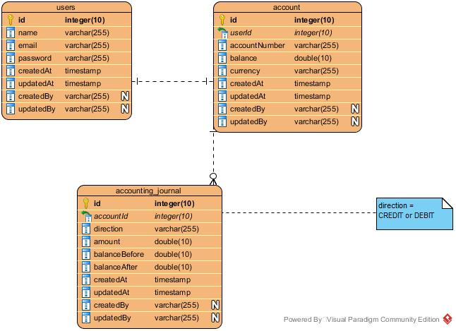

PART 1 — ARCHITECTURE (CTO APPROACH)
You are the CTO of a FinTech company planning for:
- 1 million users
- 10,000 transactions per minute
- 99.99% availability

Question 1
Propose the overall platform architecture using:
- Microservices
- API Gateway
- Service Discovery
- Centralized Configuration
Recommended Technologies
- Spring Cloud
- MongoDB
- Kafka
- Docker / Kubernetes
You are required to :
- present an architecture diagram
- explain the roles of each component
Expected examples:
- API Gateway
- Auth Service
- Accounting Service
- Transaction Service
- Notification Service
- Event Streaming

Question 2 — Dats architecture
Explain:
- How you will manage :
- account consistency
- financial transactions
- Which strategy you would choose between:
- ACID
- Eventual Consistency
- How to manage:
- auditing
- history tracking
- rollback mechanisms

Question 3 — Fintech Security
Explain how you would secure the platform:
- Authentication
- Authorization
- API protection
- Protection against:
  - replay attacks
  - brute force attacks
  - injection attacks
Possible technologies:
- Keycloak
- OAuth2
- JWT
- API rate limiting

PART 2 — MICROSERVICES DESIGN

You are required to design the following services:
Services | Duties
Auth Service | User management
Account Service | Account management
Transaction Service | Transfer management
Accounting Service | Accounting ledger (journal entries)

Question 4
Define the main REST APIs:
Examples :
POST /auth/register
POST /auth/login
GET /users/me
POST /accounts
GET /accounts/{id}
POST /transactions/transfer
GET /transactions/history

Explain :
- DTO
- Http codes
- Possible error responses

PART 3 — TECHNICAL IMPLEMENTATION
Implement a TransactionService microservice in:
- Java
- Spring Boot
- MongoDB
Functions :
POST /transactions/transfer
Payload :
{
"sourceAccount": "ACC001",
"destinationAccount": "ACC002",
"amount": 100
}
The logic must:
- verify the account balance
- debit the source account
- credit the destination account
- write two entries in the AccountingJournal

Constraints:
- transactional management
- error handling
- use of DTOs

PART 4 — EVENT DRIVEN ARCHITECTURE
After a successful transaction, an event must be published:
TransactionCompletedEvent
in Kafka.
This event must be consumable by:
- Notification Service
- Fraud Detection Service

Question:
Explain how to implement:
- the producer
- the consumer
- failure handling

PART 5 — DEVOPS
You must containerize the platform.
Expected deliverables:
- Dockerfile
- docker-compose
Basic services :
- API Gateway
- Auth Service
- Transaction Service
- MongoDB Replica Set
- Kafka
Explain as well:
- How to deploy on Kubernetes
- CI/CD strategy

PART 6 — OBSERVABILITY
Propose a monitoring solution using:
- Prometheus
- Grafana
- Loki

Questions:
Which metrics should be monitored?
Examples:
- API latency
- transaction failure rate
- CPU usage
- memory usage
- TPS (transactions per second)

PART 7 — SCALABILITY
Your platform must scale from:
10,000 → 100,000 transactions per minute

Explain:
- how you would scale the system
- what technical bottlenecks may appear

PART 8 — INCIDENT MANAGEMENT
A bug is causing: double debit on some accounts.

Explain:
- How you would detect the incident
- How you would correct the affected accounts
- How you would prevent it from happening again

EXPECTED DELIVERABLES
The candidate must provide:
- an architecture document (PDF)
- the microservices code
- a working docker-compose file
- a platform architecture diagram

CTO Evaluation Criteria
Criterion | Weight
Architecture | 30%
Technical quality | 20%
Security | 15%
Scalability | 15%
DevOps | 10%
Clarity of explanations | 10%

Good luck

